NEW FOREST PONY BREEDING AND CATTLE SOCIETY

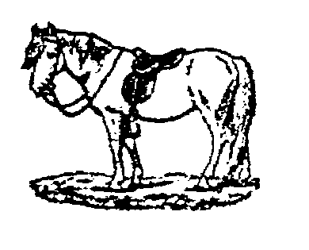
NEW FOREST PERFORMANCE PONY OF THE YEAR COMPETITION
PART-BRED PERFORMANCE PONY OF THE YEAR COMPETITION

Pony’s Name …………………………………………………………………..

Reg Number ……………………………………………………………………

Owner …………………………………………………………………………..

Address …………………………………………………………………………

……………………………………………….. Post Code …………………….

Telephone ……………………………………………………………………….

Email ………………………………………………………………………………

Please tick as appropriate
□ Owner Ridden

□ Rider, if not owner ………………………………………………………..

□ Junior Rider – (name if not owner) …………………………………………
Date of birth …………………………………………..

□ Forest-Bred

□ Novice Pony (not to have been placed in the top six in previous years)

□ Part-Bred

I have read and agreed to the rules of the competition, and enclose the entry fee of £10 / I paid the £10 fee on entering earlier in the year (delete as appropriate)

Signature of owner …………………………………………………………………

Please attach this cover sheet to your score sheets and return to the office by 31 December.

New Forest Pony Breeding and Cattle Society
Deepslade House, Ringwood Road, Bransgore, Hants BH23 8AA
Tel: 01425 672775 Email: info@newforestpony.com

